Statistical Inference Project Part 1 - A Simulation Exercise

*Jayavardhan Pujari*

## Overview:

This project investigates the Exponential distribution in R and compares it with the Central Limit Theorem.

The mean of the Exponential distribution is 1 and the standard deviation is also 1 . A thousand simulations

*λ λ*

of the distribution of 40 exponentials would be investigated.

## Simulations:

The exponential distribution can be simulated in R with rexp(n, lambda), where lambda is the rate parameter and n is the number of observations. For the purpose of all the simulations in this project, value of lambda is set to 0.2.

First we load the ggplot2 plotting library.

**library**(ggplot2)

We then initialize the simulation controlling variables.

noSim <- 1000 sampSize <- 40 lambda <- 0.2

Set the seed of the Random Number Generator, so that the analysis is reproducible.

**set.seed**(3)

Create a matrix with thousand rows corresponding to 1000 simulations and forty columns corresponding to each of 40 random simulations.

simulationMatrix <- **matrix**(**rexp**(n = noSim * sampSize, rate = lambda), noSim, sampSize)

Create a vector of thousand rows containing the mean of each row of the simulationMatrix.

simulationMean <- **rowMeans**(simulationMatrix)

Create a data frame containing the whole data.

simulationData <- **data.frame**(**cbind**(simulationMatrix, simulationMean))

We plot the simulation data to visualize it.

**ggplot**(data = simulationData, **aes**(simulationData$simulationMean)) + **geom_histogram**(breaks = **seq**(2, 9, by = 0.2), col = "blue", **aes**(fill = ..count..)) +

**labs**(title = "Histogram of Mean Distribution", x = "Simulation Means", y = "Frequency") +

**geom_vline**(**aes**(xintercept=**mean**(simulationData$simulationMean)), color="red", linetype="dashed", size=1)

100

# Histogram of Mean Distribution

75

Frequency

50

25

0

2

4 6 8

### Simulation Means

#### count

100



75

50

25

0

**Sample Mean Versus Theoretical Mean:**

The actual mean of the simulated mean sample data is 4.9866197, calculated by:

actualMean <- **mean**(simulationMean)

And the theoretical mean is 5, calculated by:

theoreticalMean <- (1 / lambda)

Thus, we can see that the actual mean of the simulated mean sample data is very close to the theoretical mean of original data distribution.

## Sample Variance Versus Theoretical Variance:

The actual variance of the simulated mean sample data is 0.6257575, calculated by:

actualVariance <- **var**(simulationMean)

And the theoretical variance is 0.625, calculated by:

theoreticalVariance <- ((1 / lambda) ^ 2) / sampSize

Thus, we can see that the actual variance of the simulated mean sample data is very close to the theoretical variance of original data distribution.

## Distribution:

To prove that the simulated mean sample data approximately follows the Normal distribution, we perform the following three steps:

#### Step 1: Create an approximate normal distribution and see how the sample data alligns with it.

**qplot**(simulationMean, geom = 'blank') +

**geom_line**(**aes**(y=..density.., colour='Empirical'), stat='density', size=1) + **stat_function**(fun=dnorm, args=**list**(mean=(1/lambda), sd=((1/lambda)/**sqrt**(sampSize))),

**aes**(colour='Normal'), size=1) + **geom_histogram**(**aes**(y=..density.., fill=..density..), alpha=0.4,

breaks = **seq**(2, 9, by = 0.2), col='red') + **scale_fill_gradient**("Density", low = "yellow", high = "red") + **scale_color_manual**(name='Density', values=**c**('brown', 'blue')) + **theme**(legend.position = **c**(0.85, 0.60)) +

**labs**(title = "Mean Density Distribution", x = "Simulation Means", y = "Density")

0.5

0.4

0.3

Density

0.2

0.1

0.0

# Mean Density Distribution

2 4 6 8



**Density**

Empirical Normal

**Density**

0.5

0.4

0.3

0.2

0.1

0.0

### Simulation Means

From above histogram, the simulated mean sample data can be adequately approximated with the normal distribution.

#### Step 2: Compare the 95% confidence intervals of the simulated mean sample data and the theoretical normally distributed data.

actualConfInterval <- actualMean+**c**(-1,1)*1.96\***sqrt**(actualVariance)/**sqrt**(sampSize) theoreticalConfInterval <- theoreticalMean+**c**(-1,1)*1.96*

**sqrt**(theoreticalVariance)/**sqrt**(sampSize)

Actual 95% confidence interval is [4.7414712, 5.2317681] and Theoretical 95% confidence interval is [4.755, 5.245] and we see that both of them are approximately same.

#### Step 3: q-q Plot for Qunatiles.

**qqnorm**(simulationMean) **qqline**(simulationMean)

**Normal Q−Q Plot**

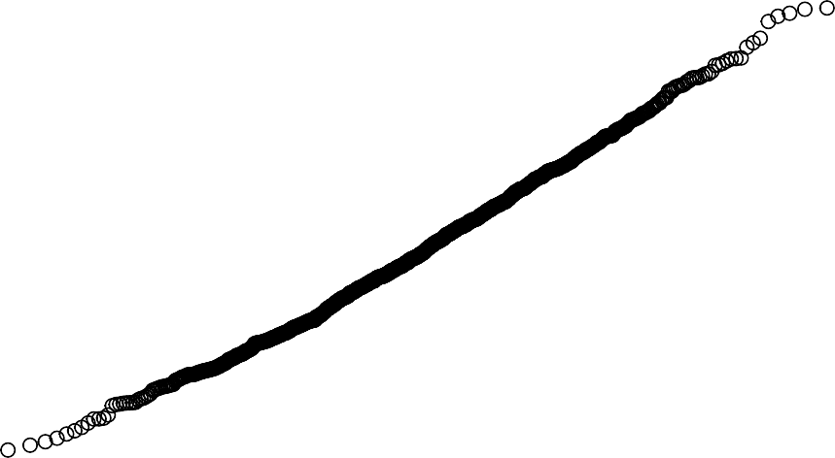

Sample Quantiles

6

7

### −3 −2 −1 0 1 2 3 Theoretical Quantiles

3

4

5

The actual quantiles also closely match the theoretical quantiles, hence the above three steps prove that the distribution is approximately normal.